APP DEV AND EMERGING TECHs

Jericho Bruce Rivero | BSIT

Activity 6

1. Write a Python program that will print the following students’ grade using the assigned grades: (A, B, C & F) based on marks obtained by the students. Display all at once.

Data:

if the percentage is above 90, assign grade A

if the percentage is above 84, assign grade B

if the percentage is above 74, assign grade C

if the percentage is below 75, assign grade F

Given students grade:

Student 1 = 84

Student 2 = 75

Student 3 = 100

Student 4 = 74

Student 5 = 64

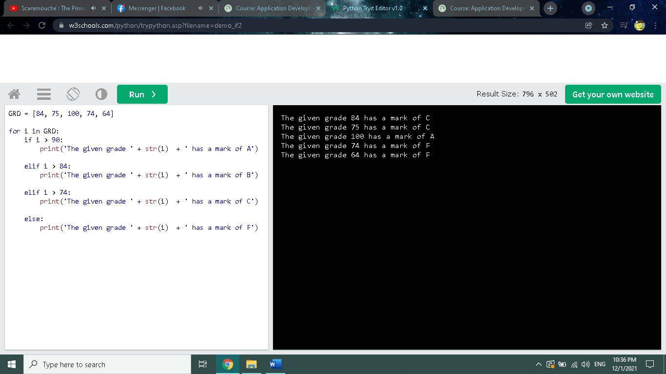

**GRD = [84, 75, 100, 74, 64]**

for i in GRD:

if i > 90:

print('The given grade ' + str(i) + ' has a mark of A')

elif i > 84:

print('The given grade ' + str(i) + ' has a mark of B')

elif i > 74:

print('The given grade ' + str(i) + ' has a mark of C')

else:

print('The given grade ' + str(i) + ' has a mark of F')